K Bar Karaoke Restaurant Menu

A. Skewers

1. Lamb skewers $15.90 for 5 2. Pork Belly Skewers $15.90 for 5
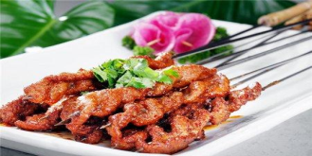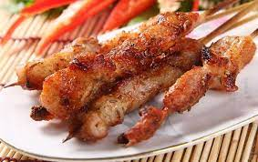

3. Beef skewers $15.90 for 5 4. Beef Fat Skewers $9.90 for 5
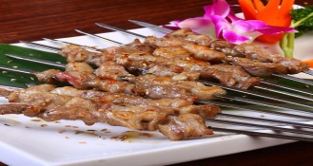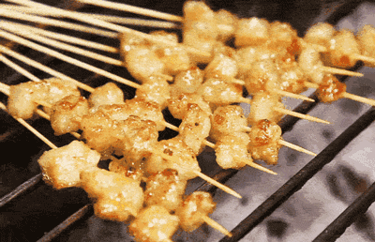

5. Beef Tongue Skewers $15.90 for 5 6. Tentacles of squid skewers $14.90 for 3
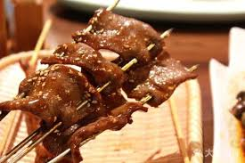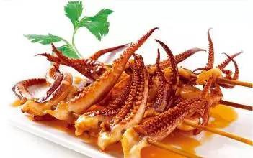

7. Fish Balls Skewers $14.90 for 5 8. Chicken skewers$14.90 for 5
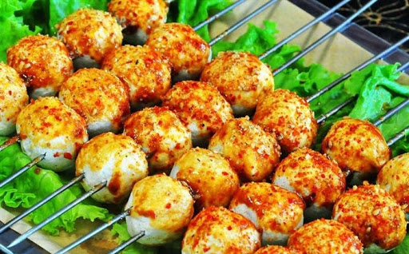

9. Fish Tofu Skewers $14.90 for 5 10. Chicken Mid Wing Skewers $14.90 for 3
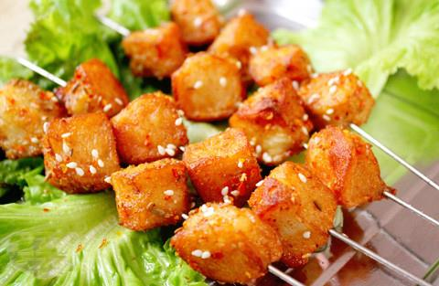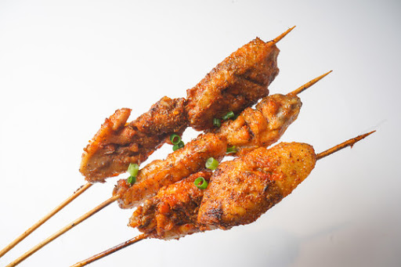

11. Crab Meat Cake Skewers $14.90 for 5 12. Chicken Skin Skewers $13.90 for 5
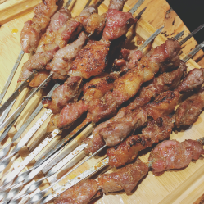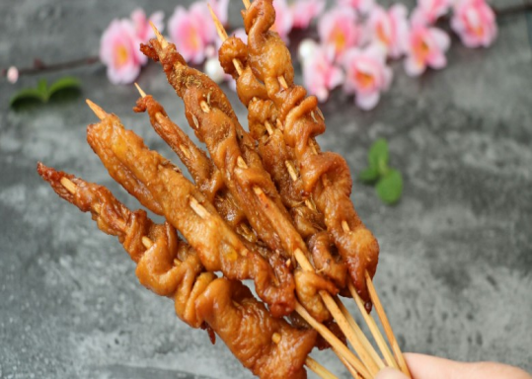

13. Chicken Heart Skewers $14.90 for 5 14. Chicken Gizzard Skewers $14.90 for 5
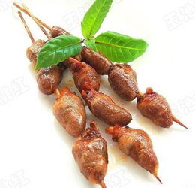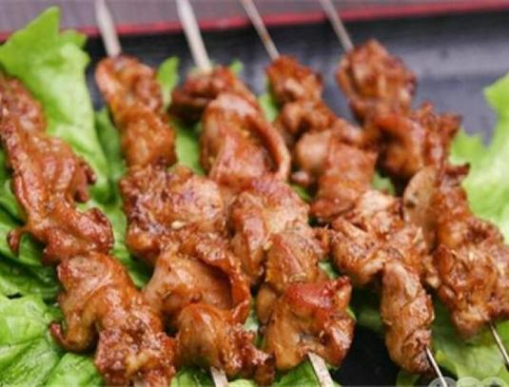

15. Chicken Knuckle Skewers $14.90 for 5 16. Gluten Skewers $13.90 for 5
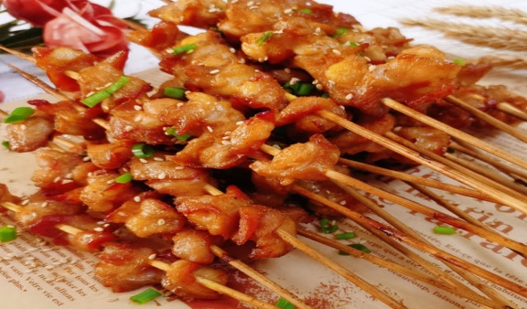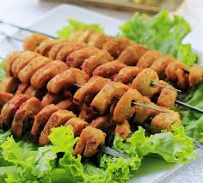
17. Garlic Bread Skewers $8.90 for 3 18. Steamed Bun Skewers $8.90 for 3
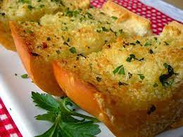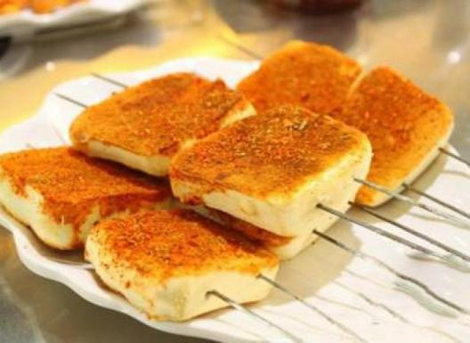

19. Leek Skewers $8.90 for 3 20. Enoki mushroom Skewers $8.90 for 3
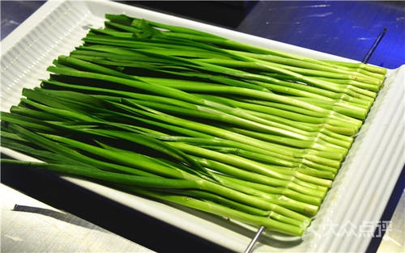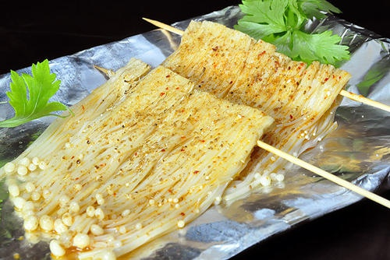

21. Green Chilli Skewers $8.90 for 3 22. Garlic Sprout Skewers $8.90 for 3
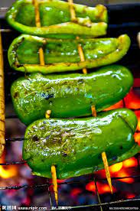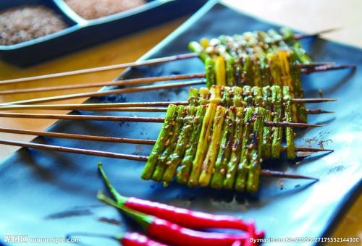

23. Lotus Root Skewers $7.90 for 3 24. Potato Chips Skewers $7.90 for 3
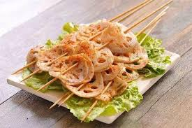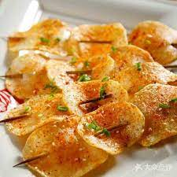
- Main Course

25. Xinjiang Spicy Chicken with Rice $17.90 26. Xinjiang Spicy Chicken with Noodle $17.90
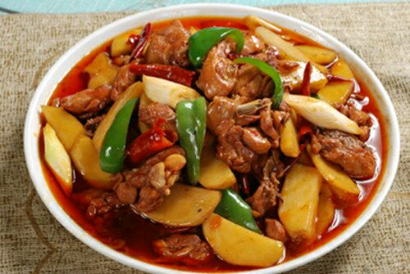

27. Xinjiang Spicy Chicken Salad $18.90 28. Twice Cooked Pork Slices $24.90
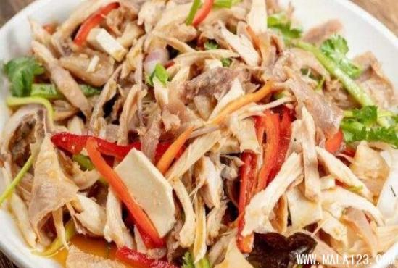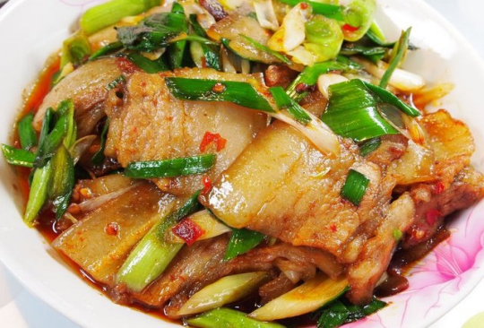

29. Xinjiang Braised Lamb Ribs $34.90 30. Spicy Chicken Salad $17.90
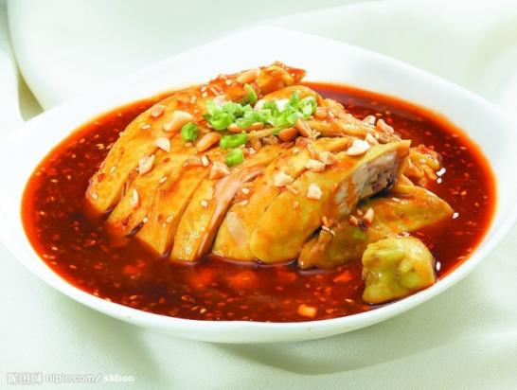

31. Spicy Beef and Offal Salad $17.90 32. Spicy Tender Tofu $10.90
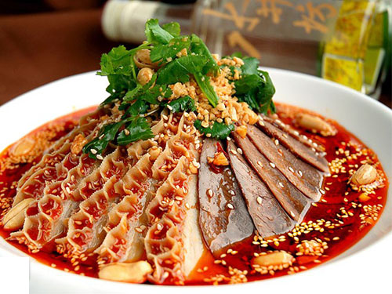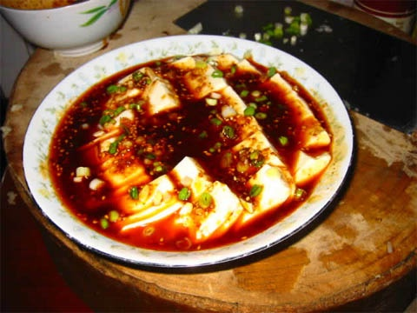
33. Salt Cooked Edamame $10.90 34. Spicy Pickled Chicken Feet $14.90
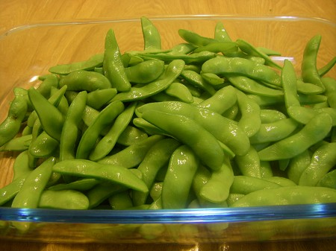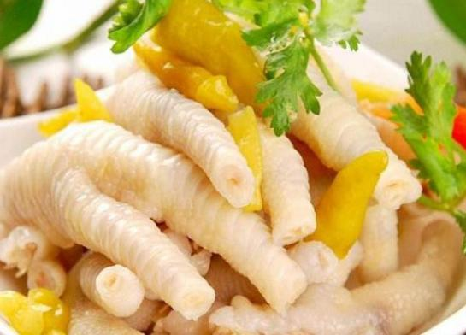

35. Hand Make Boiled Dumplings (pork) $18.90 36. Hand Make Fried Dumplings (pork) $18.90
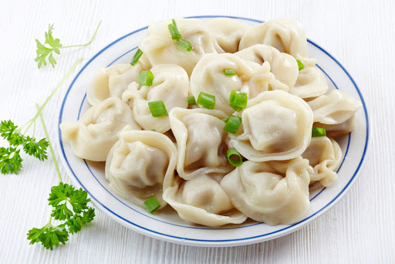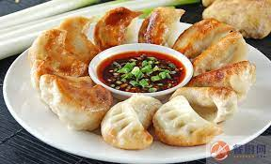

37. Xinjiang Steamed Lamb Buns $7.90 for Two 38. Xinjiang Roasted Lamb Buns $7.90 for Two
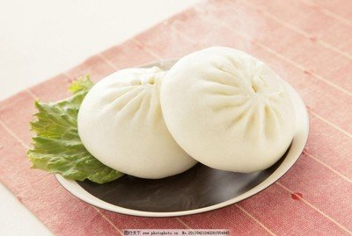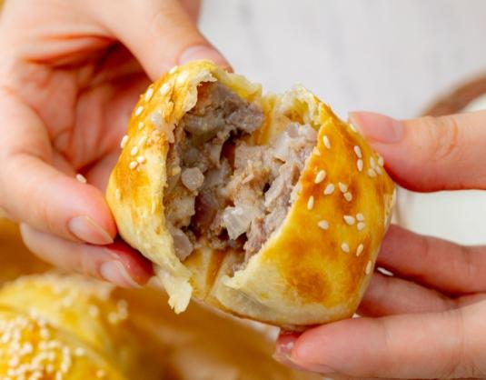

- Xinjiang Braised Lamb with Rice $19.90 40. Braised Ham with Rice and Potato $17.90
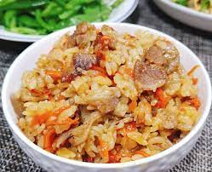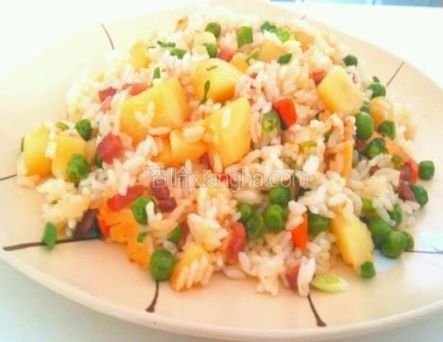
41. Spicy Hot Noodle with Chicken $14.90 42. Spicy Cold Noodle with Chicken $14.90
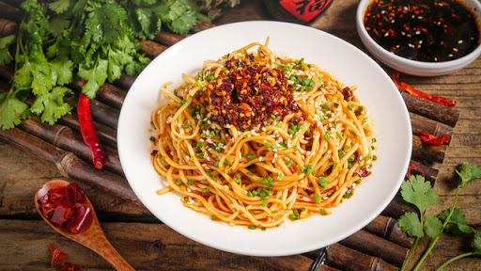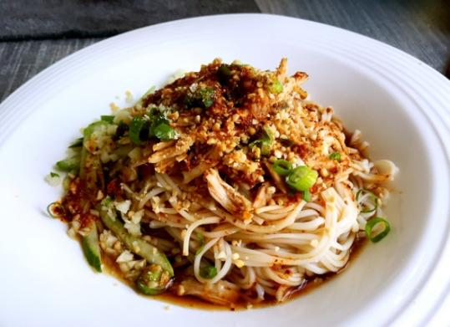

43. Grilled Spicy Eggplant $10.90 44. Steamed Rice $3.50
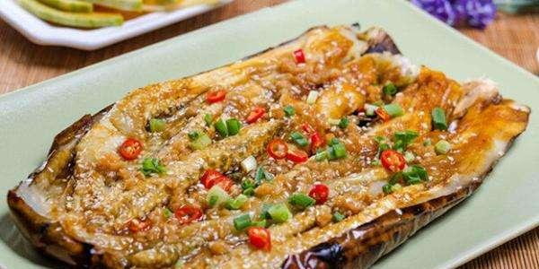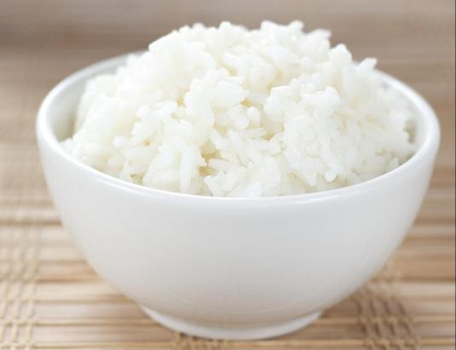

- Drinks

45. Xingjiang Style Yogurt $5.50 each 46. Coke and Sprite $3.50 each
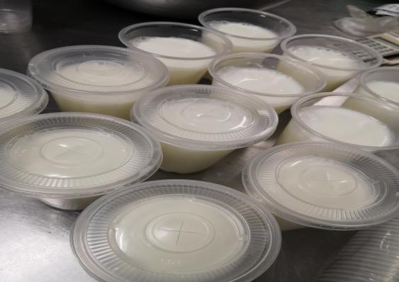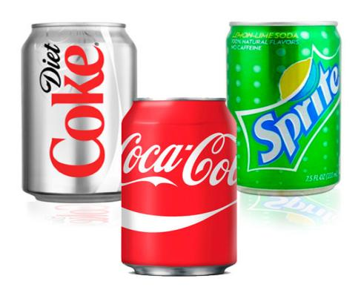

47. Ice Black Tea $3.80 47. Ice Green Tea $3.80
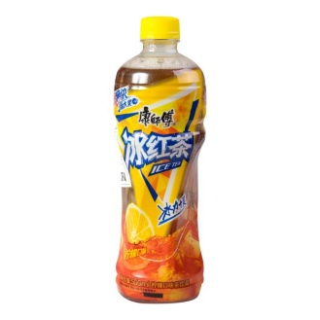

49. WLJ Herbal Tea 50. Plum juice $4.90

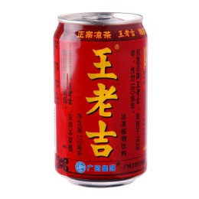
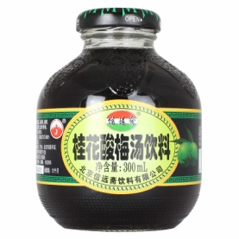

51. Red Bull Vitamin Energy Drink $4.90 52. Mother Energy Drink $4.80
